1. **EQUIVALENCE TEST**

Equivalence test (TOST approach) was performed for the following six comparisons:

**Independent groups**

1. Tilt angles during fixed and free condition
2. Safety margin of Index finger during fixed and free condition
3. Safety margin of Middle finger during fixed and free condition
4. Safety margin of Little finger during fixed and free condition

**Dependent groups**

1. Ring and little finger normal force during free condition
2. Percentage of normal force shared by ring and little fingers during free condition

**B) SESOI calculation (or equivalence bounds) for Independent groups**

(i)For a desired level of statistical power of 95%, with the sample size of 15, alpha =0.05, we get equivalence bounds **in R package as following**.

> powerTOSTtwo(alpha=0.05, N=15, statistical_power=0.95)

The equivalence bounds to achieve 95 % power with N = 15 are -1.32 and 1.32 .

[1] -1.316293 1.316293

(ii)For a desired level of statistical power of 95%, with the sample size of 15, alpha =0.05, we get smallest effect size of interest (d=SESOI) **in GPower as following** (performed for confirmation).

Effect size =1.36 (approximately same as we got in R package)

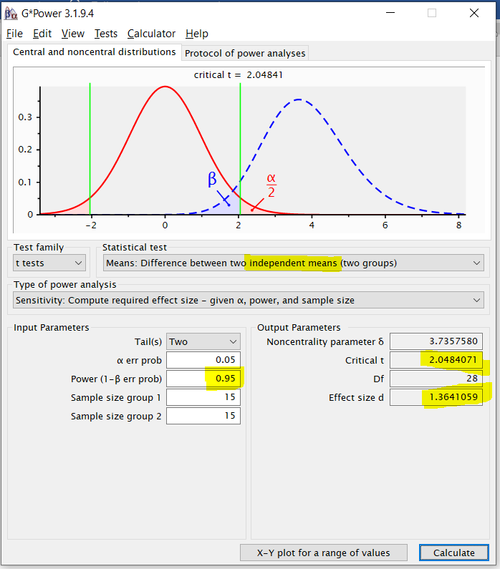

iii) Formula for equivalence bounds calculation (for independent group) used in R

Above formula for equivalence bounds derived from (Chow et al. 2007)

==SD=1 Mean=1

**qnorm** is the R function that calculates the inverse c. d. f.  of the normal distribution.By providing probability to the qnorm function, it returns associated z score. Alpha=0.05, power=0.95

**Z score of =1.645**,

95% of the values in a population that is normally distributed with mean 0 and standard deviation 1 will lie below 1.645

**=1.96**

97.5% of the values in a population that is normally distributed with mean 0 and standard deviation 1 will lie below 1.96

**n=15, we get d=1.414*(3.606/3.87)= 1.31**

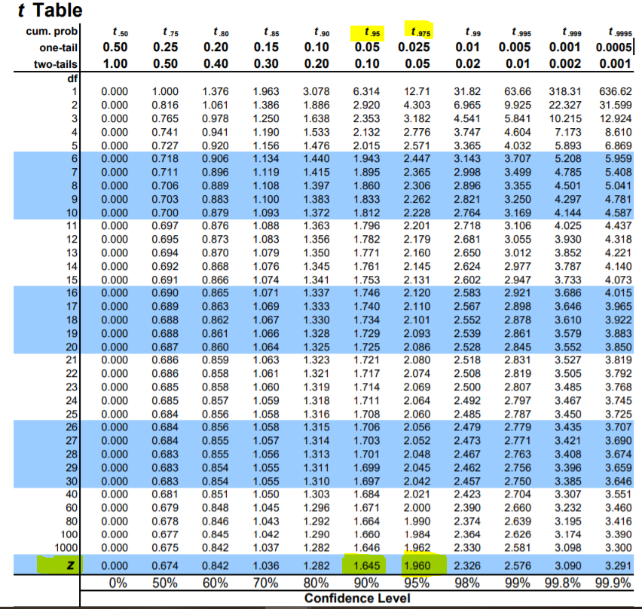

**Therefore, -1.31 was taken as lower equivalence bounds and 1.31 taken as upper equivalence bounds for tost comparisons that involved independent groups**

iv) Observed effect size calculating formula for independent groups

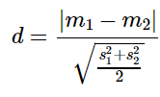

Observed effect size for tilt angle data from GPower= 0.1402

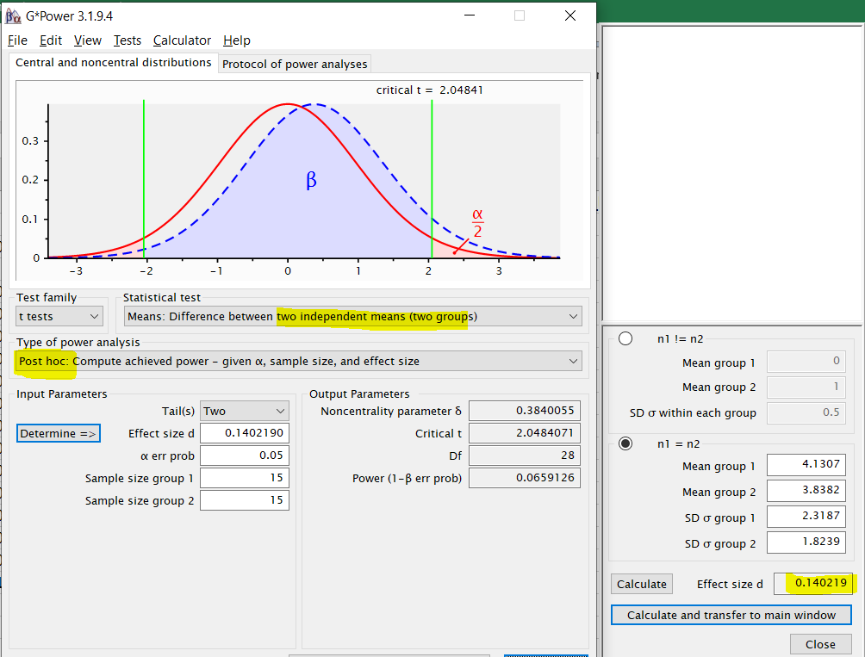

**C) SESOI calculation (or equivalence bounds) for dependent groups**

(i)For a desired level of statistical power of 95%, with the sample size of 15, alpha =0.05, we get equivalence bounds **in R package as following**.

> powerTOSTpaired(alpha=0.05, N=15, statistical_power=0.95)

The equivalence bounds to achieve 95 % power with N = 15 are -0.93 and 0.93 .

[1] -0.9307599 0.9307599

(ii)For a desired level of statistical power of 95%, with the sample size of 15, alpha =0.05, we get smallest effect size of interest (dz=SESOI) **in GPower as following** (performed for confirmation).

Effect size (equivalence bound) =1.002 (approximately same as we got in R package)

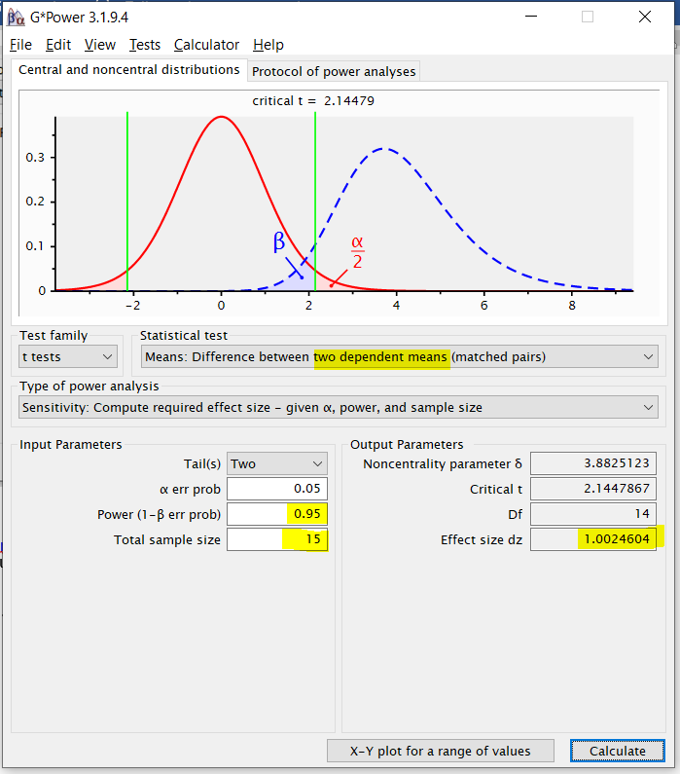

iii) Formula for equivalence bounds calculation (for dependent group)

**n=15, we get dz=(3.606/3.87)= 0.931**

**The relationship between Cohen’s d and dz is a factor of**

(Lakens,2017)

**Therefore, -0.93 was taken as lower equivalence bounds and 0.93 taken as upper equivalence bounds for tost comparisons that involved dependent groups**

iv) Observed effect size calculating formula for **dependent groups**

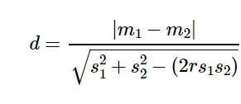

Observed effect size for Ring and little finger normal force data from GPower= 0.1407

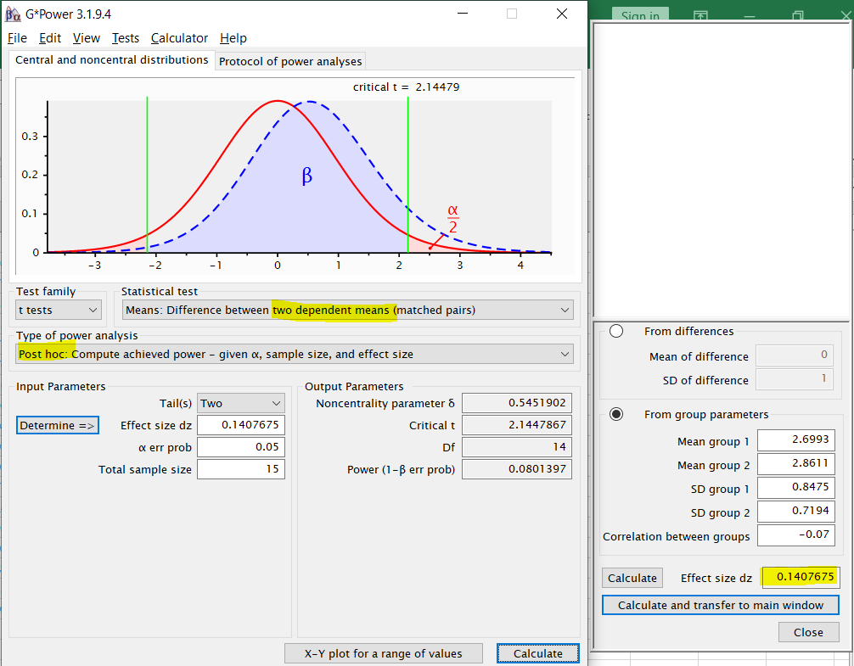

**TOST Results from R package**

1. **Tilt angle data during fixed and free condition**

> TOSTtwo(m1=4.13,m2=3.83,sd1=2.31,sd2=1.82,n1=15,n2=15,low_eqbound=-1.31,high_eqbound=1.31,0.05,var.equal=TRUE)

TOST results:

t-value lower bound: 3.98 p-value lower bound: 0.0002

t-value upper bound: -3.19 p-value upper bound: 0.002

degrees of freedom : 28

Equivalence bounds (Cohen's d):

low eqbound: -1.31

high eqbound: 1.31

Equivalence bounds (raw scores):

low eqbound: -2.7241

high eqbound: 2.7241

TOST confidence interval:

lower bound 90% CI: -0.992

upper bound 90% CI: 1.592

NHST confidence interval:

lower bound 95% CI: -1.255

upper bound 95% CI: 1.855

Equivalence Test Result:

The equivalence test was significant, t(28) = -3.192, p = 0.00174, given equivalence bounds of -2.724 and 2.724 (on a raw scale) and an alpha of 0.05.

Null Hypothesis Test Result:

The null hypothesis test was non-significant, t(28) = 0.395, p = 0.696, given an alpha of 0.05.

Based on the equivalence test and the null-hypothesis test combined, we can conclude that the observed effect is statistically not different from zero and statistically equivalent to zero.

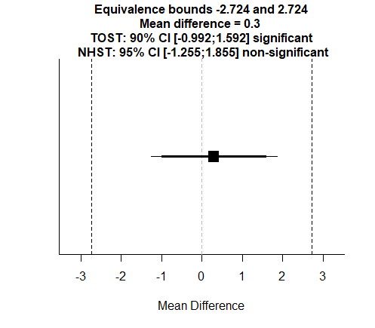

Observed effect size



1. **SMz_Index_fixed vs SMz_Index_free**

> TOSTtwo(m1=0.4580, m2=0.5540,sd1=0.26,sd2=0.25,n1=15,n2=15,low_eqbound=-1.31,high_eqbound=1.31,var.equal=TRUE)

TOST results:

t-value lower bound: 2.56 p-value lower bound: 0.008

t-value upper bound: -4.62 p-value upper bound: 0.00004

degrees of freedom : 28

Equivalence bounds (Cohen's d):

low eqbound: -1.31

high eqbound: 1.31

Equivalence bounds (raw scores):

low eqbound: -0.3341

high eqbound: 0.3341

TOST confidence interval:

lower bound 90% CI: -0.254

upper bound 90% CI: 0.062

NHST confidence interval:

lower bound 95% CI: -0.287

upper bound 95% CI: 0.095

Equivalence Test Result:

The equivalence test was significant, t(28) = 2.557, p = 0.00814, given equivalence bounds of -0.334 and 0.334 (on a raw scale) and an alpha of 0.05.

Null Hypothesis Test Result:

The null hypothesis test was non-significant, t(28) = -1.031, p = 0.311, given an alpha of 0.05.

Based on the equivalence test and the null-hypothesis test combined, we can conclude that the observed effect is statistically not different from zero and statistically equivalent to zero.

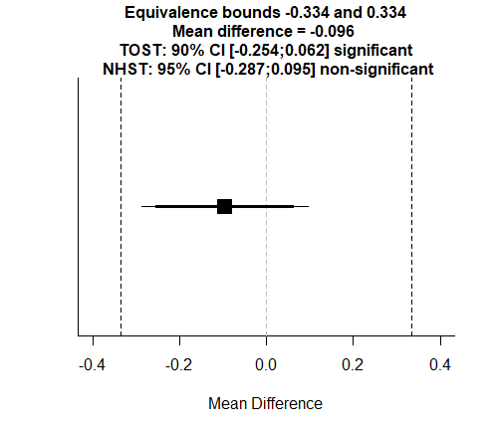

Observed effect size

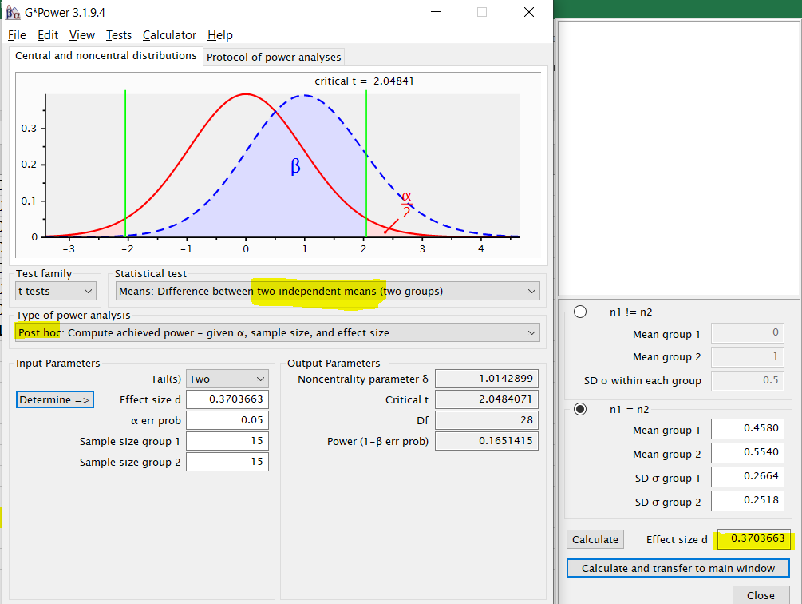

1. **SMz_Middle_fixed vs SMz_ Middle_free**

> TOSTtwo(m1=0.2022, m2=0.3591,sd1=0.19,sd2=0.28,n1=15,n2=15,low_eqbound=-1.31,high_eqbound=1.31,var.equal=TRUE)

TOST results:

t-value lower bound: 1.79 p-value lower bound: 0.042

t-value upper bound: -5.38 p-value upper bound: 0.000005

degrees of freedom : 28

Equivalence bounds (Cohen's d):

low eqbound: -1.31

high eqbound: 1.31

Equivalence bounds (raw scores):

low eqbound: -0.3134

high eqbound: 0.3134

TOST confidence interval:

lower bound 90% CI: -0.306

upper bound 90% CI: -0.008

NHST confidence interval:

lower bound 95% CI: -0.336

upper bound 95% CI: 0.022

Equivalence Test Result:

The equivalence test was significant, t(28) = 1.792, p = 0.042, given equivalence bounds of -0.313 and 0.313 (on a raw scale) and an alpha of 0.05.

Null Hypothesis Test Result:

The null hypothesis test was non-significant, t(28) = -1.796, p = 0.0833, given an alpha of 0.05.

Based on the equivalence test and the null-hypothesis test combined, we can conclude that the observed effect is statistically not different from zero and statistically equivalent to zero.

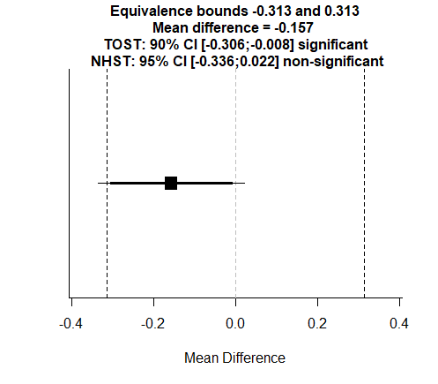

Observed effect size

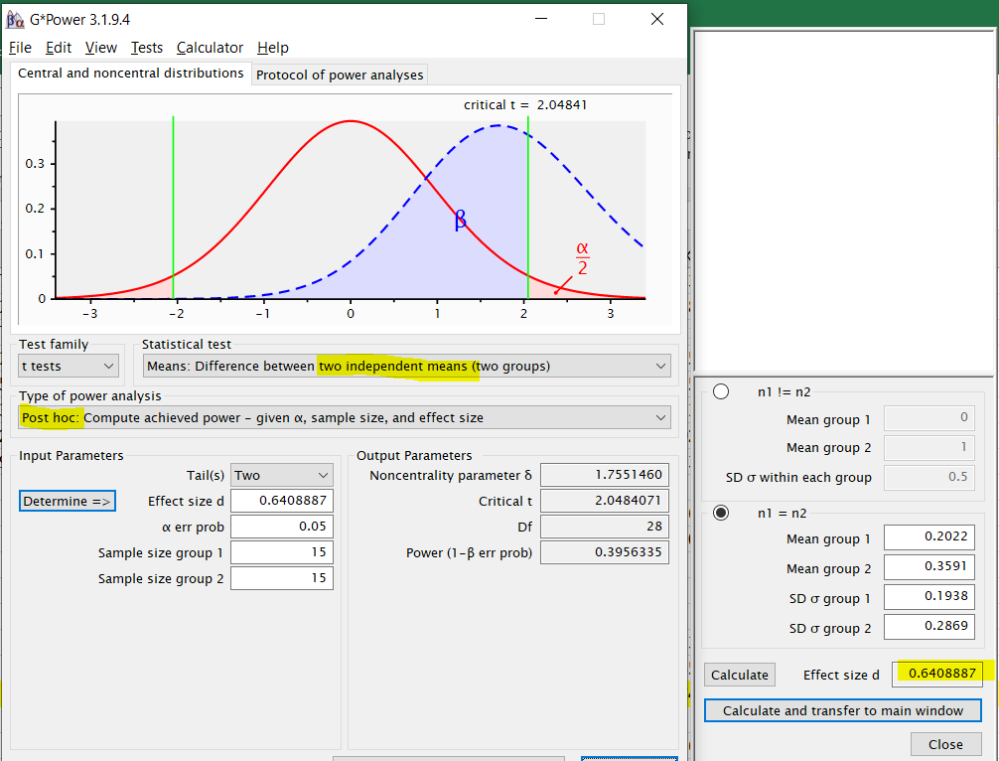

1. **SMz_Little_fixed vs SMz_Little_free**

> TOSTtwo(m1=0.7063, m2=0.6659,sd1=0.19,sd2=0.19,n1=15,n2=15,low_eqbound=-1.31,high_eqbound=1.31,var.equal=TRUE)

TOST results:

t-value lower bound: 4.17 p-value lower bound: 0.0001

t-value upper bound: -3.01 p-value upper bound: 0.003

degrees of freedom : 28

Equivalence bounds (Cohen's d):

low eqbound: -1.31

high eqbound: 1.31

Equivalence bounds (raw scores):

low eqbound: -0.2489

high eqbound: 0.2489

TOST confidence interval:

lower bound 90% CI: -0.078

upper bound 90% CI: 0.158

NHST confidence interval:

lower bound 95% CI: -0.102

upper bound 95% CI: 0.183

Equivalence Test Result:

The equivalence test was significant, t(28) = -3.005, p = 0.00277, given equivalence bounds of -0.249 and 0.249 (on a raw scale) and an alpha of 0.05.

Null Hypothesis Test Result:

The null hypothesis test was non-significant, t(28) = 0.582, p = 0.565, given an alpha of 0.05.

Based on the equivalence test and the null-hypothesis test combined, we can conclude that the observed effect is statistically not different from zero and statistically equivalent to zero.

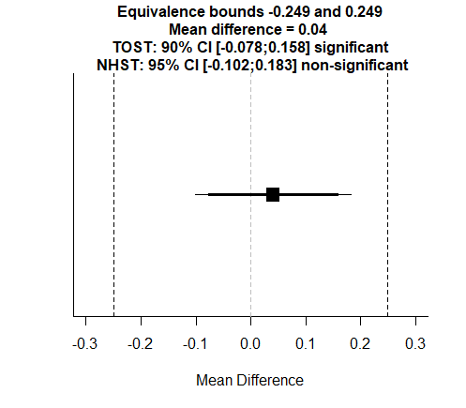

Observed effect size

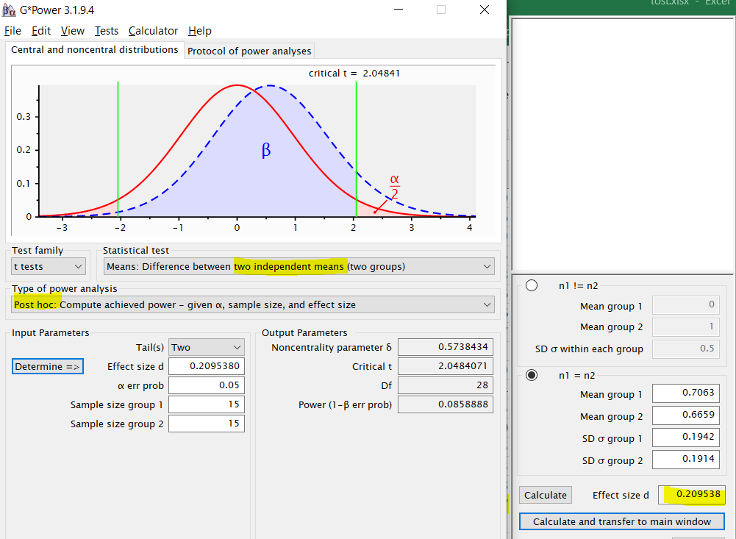

**5)Ring and little finger Normal force during free condition**

> TOSTpaired(n=15,m1=2.6993, m2=2.8611,sd1=0.8475,sd2=0.7194,r12=-0.079,low_eqbound_dz=-0.93,high_eqbound_dz=0.93)

TOST results:

t-value lower bound: 3.06 p-value lower bound: 0.004

t-value upper bound: -4.14 p-value upper bound: 0.0005

degrees of freedom : 14

Equivalence bounds (Cohen's dz):

low eqbound: -0.93

high eqbound: 0.93

Equivalence bounds (raw scores):

low eqbound: -1.0734

high eqbound: 1.0734

TOST confidence interval:

lower bound 90% CI: -0.687

upper bound 90% CI: 0.363

NHST confidence interval:

lower bound 95% CI: -0.801

upper bound 95% CI: 0.477

Equivalence Test Result:

The equivalence test was significant, t(14) = 3.059, p = 0.00425, given equivalence bounds of -1.073 and 1.073 (on a raw scale) and an alpha of 0.05.

Null Hypothesis Test Result:

The null hypothesis test was non-significant, t(14) = -0.543, p = 0.596, given an alpha of 0.05.

Based on the equivalence test and the null-hypothesis test combined, we can conclude that the observed effect is statistically not different from zero and statistically equivalent to zero.

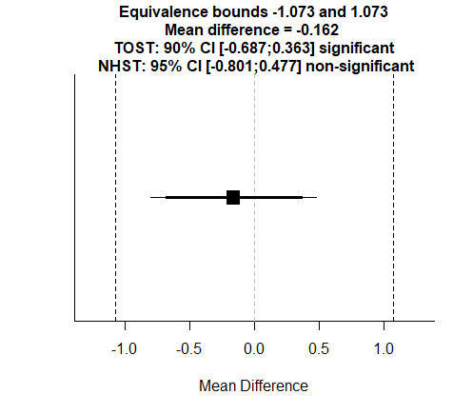

Observed effect size



**5****)% of Ring and little finger Normal force shared during free condition**

> TOSTpaired(n=15,m1=30.97, m2=33.35,sd1=8.25,sd2=7.20,r12=-0.66,low_eqbound_dz=-0.93,high_eqbound_dz=0.93)

TOST results:

t-value lower bound: 2.95 p-value lower bound: 0.005

t-value upper bound: -4.26 p-value upper bound: 0.0004

degrees of freedom : 14

Equivalence bounds (Cohen's dz):

low eqbound: -0.93

high eqbound: 0.93

Equivalence bounds (raw scores):

low eqbound: -13.0965

high eqbound: 13.0965

TOST confidence interval:

lower bound 90% CI: -8.784

upper bound 90% CI: 4.024

NHST confidence interval:

lower bound 95% CI: -10.179

upper bound 95% CI: 5.419

Equivalence Test Result:

The equivalence test was significant, t(14) = 2.947, p = 0.0053, given equivalence bounds of -13.097 and 13.097 (on a raw scale) and an alpha of 0.05.

Null Hypothesis Test Result:

The null hypothesis test was non-significant, t(14) = -0.655, p = 0.523, given an alpha of 0.05.

Based on the equivalence test and the null-hypothesis test combined, we can conclude that the observed effect is statistically not different from zero and statistically equivalent to zero.

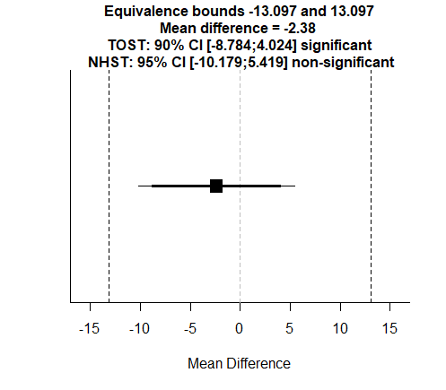

Observed effect size

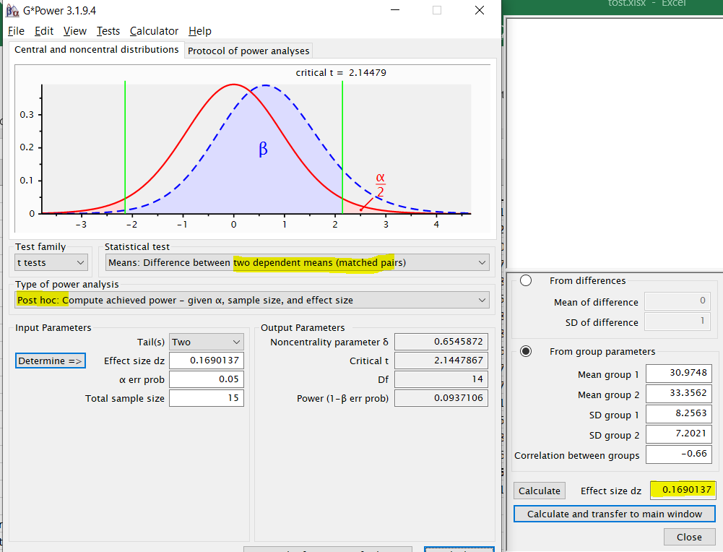

**SUMMARY**

|  |  |  |  |  |  |  |  |  |
| --- | --- | --- | --- | --- | --- | --- | --- | --- |
| **COMPARISON** | **OBSERVED EFFECT SIZE** | **STANDARDISED EQUIVALENCE BOUNDS** | | **NULL HYPOTHESIS TEST** | | **TOST TEST** | | **EQUIVALENT**  **(YES/NO)** |
| **LOWER LIMIT** | **UPPER LIMIT** | **t values** | **p values** | **t values** | **p values** |
| Tilt angle (fixed and free conditions) | d= 0.1402 | -1.31 | 1.31 | t(28) = 0.395 | p = 0.696 | t(28) =  -3.192 | p = 0.00174 | Yes |
| Safety Margin of index (fixed and free conditions) | d= 0.3703 | -1.31 | 1.31 | t(28) = -1.031 | p = 0.311 | t(28) = 2.557 | p = 0.00814 | Yes |
| Safety Margin of Middle (fixed and free conditions) | d= 0.6408 | -1.31 | 1.31 | t(28) = -1.796 | p = 0.0833 | t(28) = 1.792 | p = 0.042 | Yes |
| Safety Margin of little (fixed and free conditions) | d= 0.2095 | -1.31 | 1.31 | t(28) = 0.582 | p = 0.565 | t(28) = -3.005 | p = 0.00277 | Yes |
| R and L Normal force (free condition) | dz=0.1407 | -0.93 | 0.93 | t(14) = -0.543 | p = 0.596 | t(14) = 3.059 | p = 0.00425 | Yes |
| % of Normal force shared by R and L (free condition) | dz=0.1690 | -0.93 | 0.93 | t(14) = -0.655 | p = 0.523 | t(14) = 2.947 | p = 0.0053 | Yes |

**REFERENCES**

Chow, S.-C., Wang, H., & Shao, J. (2007). Sample Size Calculations in Clinical Research, Second Edition - CRC Press Book. Pg 28

Lakens, D. (2017). Equivalence tests: a practical primer for t tests, correlations, and meta-analyses. *Social psychological and personality science*, *8*(4), 355-362.